Program 9:

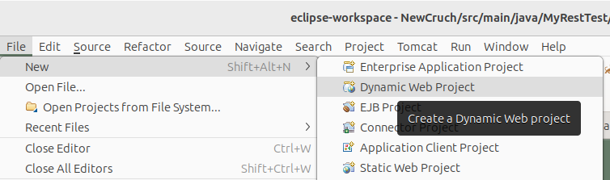

POM.xml

<dependencies>
<dependency>
<groupId>asm</groupId>
<artifactId>asm</artifactId>
<version>3.3.1</version>
</dependency>
<dependency>
<groupId>com.sun.jersey</groupId>
<artifactId>jersey-bundle</artifactId>
<version>1.19.4</version>
</dependency>
<dependency>
<groupId>org.json</groupId>
<artifactId>json</artifactId>
<version>20170516</version>
</dependency>
<dependency>
<groupId>com.sun.jersey</groupId>
<artifactId>jersey-server</artifactId>
<version>1.19.4</version>
</dependency>
<dependency>
<groupId>com.sun.jersey</groupId>
<artifactId>jersey-core</artifactId>
<version>1.19.4</version>
</dependency>
</dependencies>

add the jar files in the following folder:
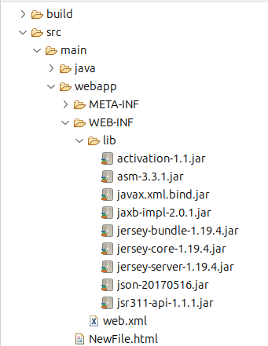

update web.xml

<servlet>
<servlet-name>Jersey Web Application</servlet-name>
<servlet-class>com.sun.jersey.spi.container.servlet.ServletContainer</servlet-class>
<load-on-startup>1</load-on-startup>
</servlet>
<servlet-mapping>
<servlet-name>Jersey Web Application</servlet-name>
<url-pattern>/rest/*</url-pattern>
</servlet-mapping>

program:

package MyRestTest;

import javax.ws.rs.DELETE;
import javax.ws.rs.GET;
import javax.ws.rs.POST;
import javax.ws.rs.PUT;
import javax.ws.rs.Path;
import javax.ws.rs.Produces;

@Path("/home")
public class TestRestBasedAPP {

@GET
@Produces("text/html")
public String getMethod() {
return "Hello from REST based API";
}

@POST
@Path("/post")
@Produces("text/html")
public String postMethod() {
return "In the post method Hello from REST based API";
}

@PUT
@Produces("text/html")
public String putMethod() {
return "In the put method Hello from REST based API";
}

@DELETE
@Produces("text/html")
public String delteMethod() {
return "In the post method Hello from REST based API";
}

}

check folder with jar files

